梁基安主任 口頭複習 2013/8/27

- BRCA 1 and BRCA 2 (tumor suppressor gene): 5-10% of breast ca, young age, bilateral
TUMOR SUPPRESSOR GENE | BRCA-1 | BRCA-2
Breast ca risk | 40-85% | 40-85%
Ovarian ca risk | 45% | <10%
Dominant subtype | Triple negative | Hormone dependent

- IMN 轉移的比例:
 | 內上 | 內下 | 中央 | 外側
Axilla LN (-) | 14% | 6% | 7% | 5%
Axilla LN(+) | 45% | 72% | 46% | 20%
- IMN detected by Radioactive tracer injection/Blue dye: 外側lesion 15% ; 內側 30-50% ; Biopsy proof IMN positive rate 15%

- Hypofractionation whole breast RT:
符合以下條件的病人，用convention whole bresast RT 與 hypoFx RT 兩者治療效果相同
- Age ≧50
- pT1-2N0 w/o chemotherapy
- Radiation dose homogeneity within ±7% in the central axis plane
- Heart should be excluded from the treatment field

對於不需要 tumor bed boost 的病人，ASTRO推薦使用 42.5Gy/16Fr的schedule，tumor bed boost under hypofractionation並不認為是恰當的
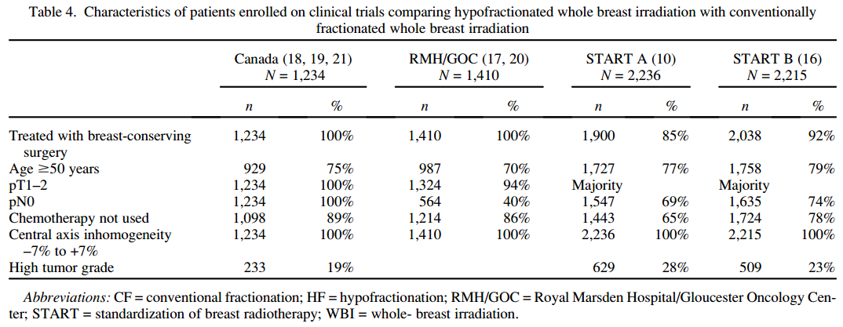
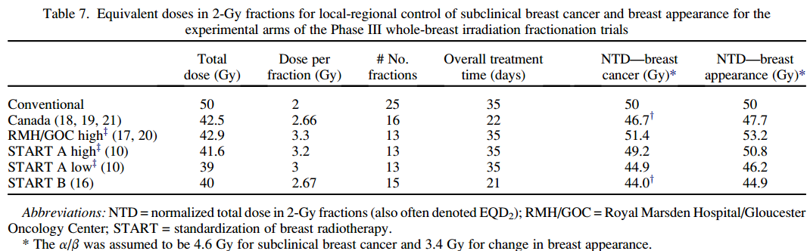

- APBI consensus guideline: ASTROa and ESTRO 的差別
ESTRO
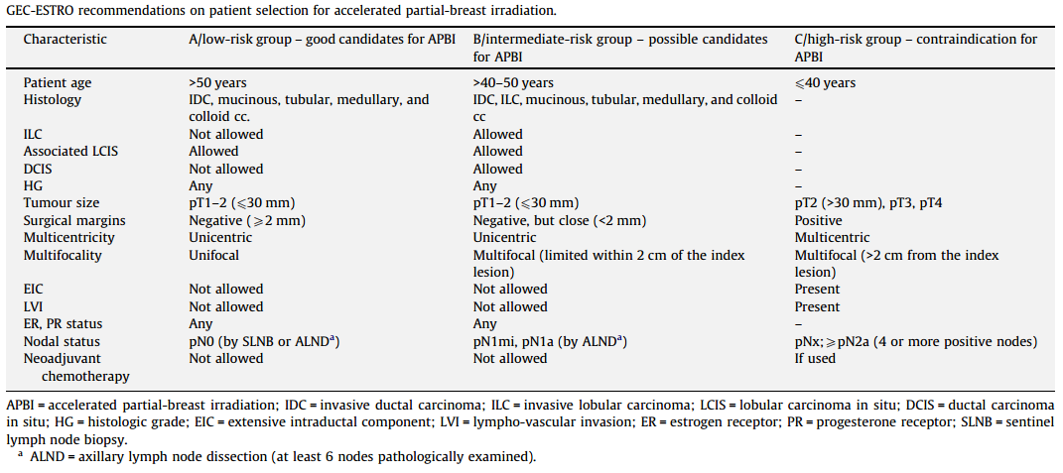
ASTRO:
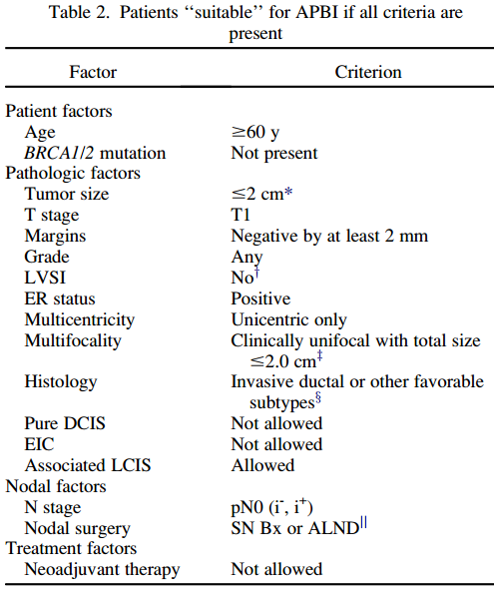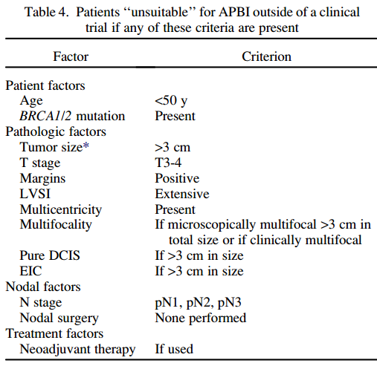

- Breast RT 的 heart toxicity : NEJM 2013 population-based case–control study from Sweden and Denmark
- mean doses to the whole heart was 4.9 Gy
- major coronary events increased linearly with the mean dose to the heart by 7.4% per gray (w/o threshold)
- Increase from the 5th year to 30 yrs
- The major cardiac event risk increased both in woman with or w/o cardiac risk at diagnosis
- Women with preexisting cardiac risk factors have greater absolute increases in risk from radiotherapy than other women 原先就有心臟病的風險會更高
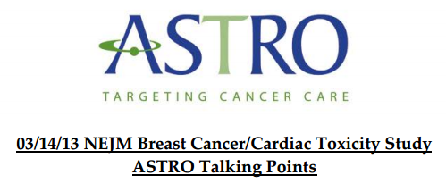
ASTRO的回應
- Benefit of radiation outweight the risks of cardiac toxicity in woman for whom radiation is indicated
- Current technique reduced heart dose compared with older tech (NEJM retrospective review 1958-2001 w/ old tech)
- even with older technologies and slightly increased risk of cardiac events, there is a substantial and significant overall survival and breast cancer mortality benefit with radiation
- With modern technology, the risk of cardiac exposure can be minimized to levels far below those achieved in previous decades.

- 2nd malignancy rate after breast cancer treatment: 1/200 (0.5%)

- Brain mets, n=1, RPA=1, size 2.5cm 依照 ASTRO guideline有哪些治療是 level I evidence?
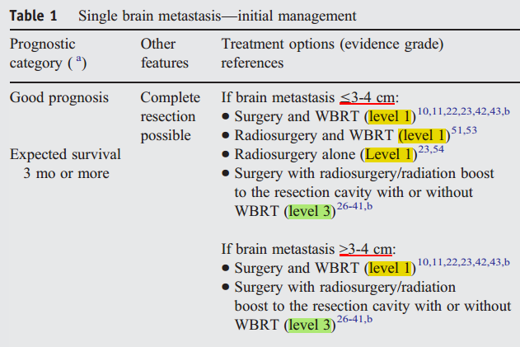

- Breast cancer subtype: ki-67 14%
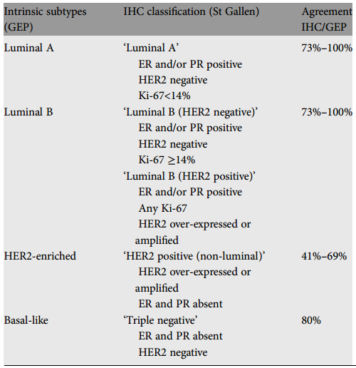

- Bone mets 8Gy x 1 與 30Gy/10Fr 的 retreat rate : 9% and 18%
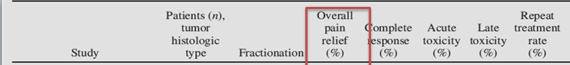

- Phyllodes tumor 的治療
- Origin: 包含了 stroma and epithelial elements (cystosarcoma phyllodes) (Leaf like, lobulated appearance microscopiclly)
- Benign to malignant 都有
- 最重要的預後因子為R0 resection，手術邊緣要切乾淨
- 建議用 excisional biopsy，若結果為 Phyllodes tumor，不管為 benign , borderline, or malignant tumor 都應該接受 wide excision，不需要做 axillary node dissection
- 淋巴轉移機會為10% (NCCN 建議 wide excision w/o axillary staging)
- 若局部復發沒有遠處轉移 (stromal component會遠處轉移)，進行再切除 直到margin clear，術後 adj RT 的建議為 category 2B ;
- 若有遠處轉移則依照 soft tissue sarcoma的治療方式

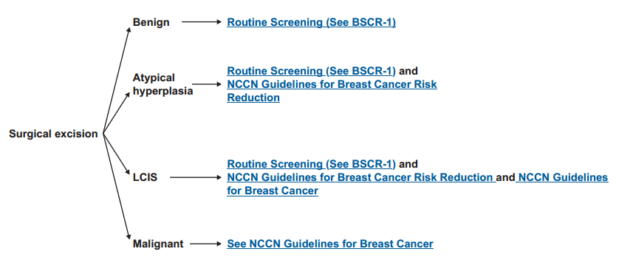
- LCIS 的治療

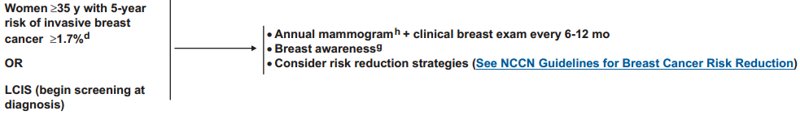

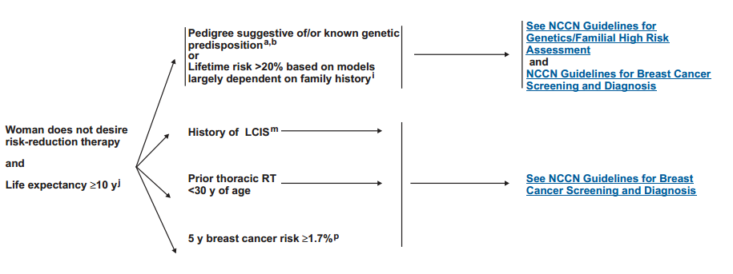

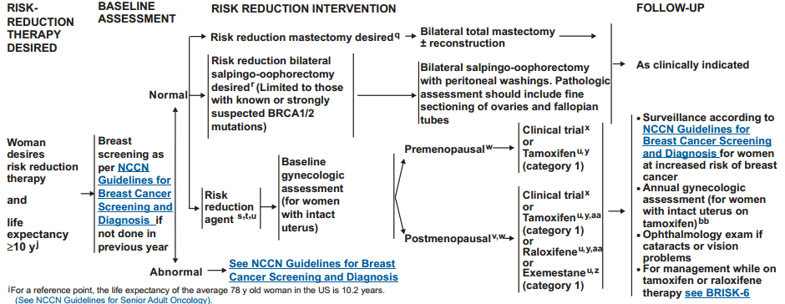

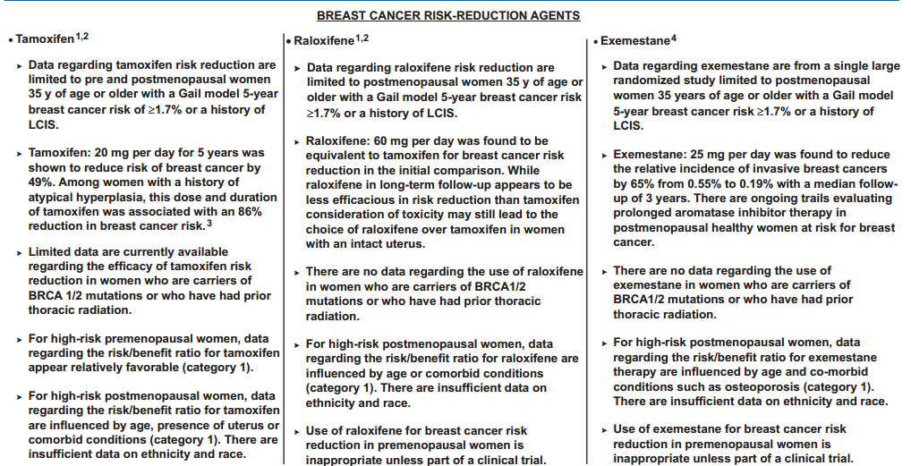

- Paget’s disease 的治療

